ravelScoot® Owner's Manual

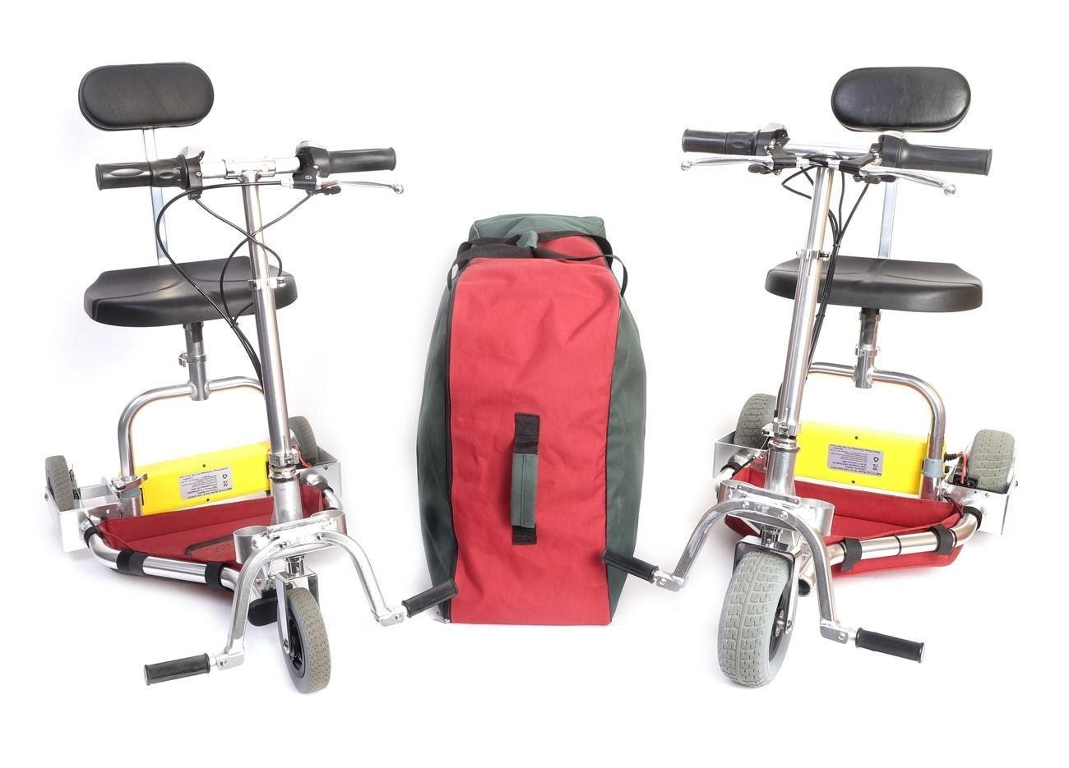

Please read all important safety information before riding your TravelScoot for the first time.

TravelScoot Parts
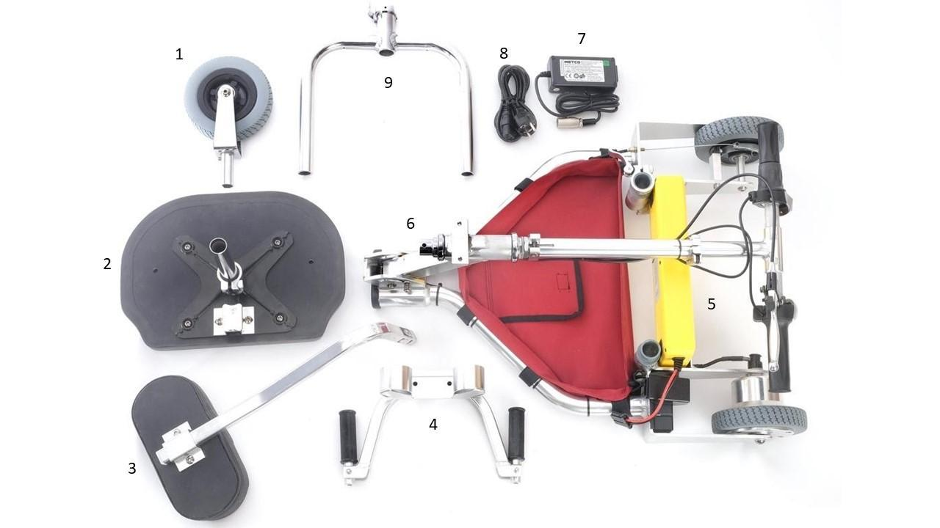
Please ensure that you have the following parts when you unpack your TravelScoot for the first time:

- Wide front wheel | 4. Footrest assembly
- Seat cushion and post | 5.Lithium-ion battery
- Backrest | 6. Yoke

Please keep the original box for returns or warranty-related shipping.

Table of Contents

Introduction. . . . . . . . . . . . . . . . . . . . . . . . . . . . . . . . . . . . . . . . . . . . . . . . . . . . . . . . . . . . . . . . . . . . . . . . . . . . . . . . . . . . . . . . Pg. 4

Terms and Conditions . . . . . . . . . . . . . . . . . . . . . . . . . . . . . . . . . . . . . . . . . . . . . . . . . . . . . . . . . . . . . . . . . . . . . . . . . . . . . . . Pg. 5

Important Safety Information . . . . . . . . . . . . . . . . . . . . . . . . . . . . . . . . . . . . . . . . . . . . . . . . . . . . . . . . . . . . . . . . . . . . . . . . Pg. 6
General Safety and Slopes, Maneuverability, Pre-Ride Safety Check, Indoor Use, Outdoor Use, Securing the TravelScoot

Assembling your TravelScoot . . . . . . . . . . . . . . . . . . . . . . . . . . . . . . . . . . . . . . . . . . . . . . . . . . . . . . . . . . . . . . . . . . . . . . . . Pg. 8

Battery Charging Procedures . . . . . . . . . . . . . . . . . . . . . . . . . . . . . . . . . . . . . . . . . . . . . . . . . . . . . . . . . . . . . . . . . . . . . . . . Pg. 10
Additional Battery Information, Battery Info for Foreign Travel,
Battery Tips

Getting on and off your Scooter . . . . . . . . . . . . . . . . . . . . . . . . . . . . . . . . . . . . . . . . . . . . . . . . . . . . . . . . . . . . . . . . . . . . . . Pg. 11

Operating your TravelScoot . . . . . . . . . . . . . . . . . . . . . . . . . . . . . . . . . . . . . . . . . . . . . . . . . . . . . . . . . . . . . . . . . . . . . . . . . Pg. 13
Connecting the Battery, On/Off Switch and Forward/Reverse Selector,
Throttle, Brake Levers, Parking Brakes,
Seat Spacers, Turning with your TravelScoot

Maintenance . . . . . . . . . . . . . . . . . . . . . . . . . . . . . . . . . . . . . . . . . . . . . . . . . . . . . . . . . . . . . . . . . . . . . . . . . . . . . . . . . . . . . . Pg. 14
Cleaning Tips
Brakes, Lubrication, Tightening

Travel . . . . . . . . . . . . . . . . . . . . . . . . . . . . . . . . . . . . . . . . . . . . . . . . . . . . . . . . . . . . . . . . . . . . . . . . . . . . . . . . . . . . . . . . . . . . Pg. 15
Air Travel
Cruise Ship Travel

Specifications . . . . . . . . . . . . . . . . . . . . . . . . . . . . . . . . . . . . . . . . . . . . . . . . . . . . . . . . . . . . . . . . . . . . . . . . . . . . . . . . . . . . . Pg. 17

TravelScoot Components and Controls . . . . . . . . . . . . . . . . . . . . . . . . . . . . . . . . . . . . . . . . . . . . . . . . . . . . . . . . . . . . . . . Pg. 18

Introduction
Congratulations on your purchase of the TravelScoot electric mobility scooter! The TravelScoot combines state-of-the-art components with safety, comfort, and portability in mind. We are confident its design will provide you with the conveniences you expect during your daily activities and travelling abroad.
This owner’s manual will provide you with valuable information about the proper use, care, and maintenance of your new scooter. Understanding how to safely operate and care for your scooter should give you many years of trouble-free scooting. Please take a few moments and read these instructions thoroughly to familiarize yourself with all aspects of the TravelScoot.
NOTE: This owner’s manual is based on the latest specifications and product information available at the time of publication. We reserve the right to make technical as well as editorial changes as they become necessary. Any changes to our products may cause slight variations between the illustrations and explanations in this manual and the product you have purchased.
Product Support
TravelScoot USA Inc., is the sole distributor for the United States. We provide support and replacement parts for all products sold by TravelScoot USA. You should be able to find answers to most of your inquiries on our website. There, you will find all our YouTube videos, repair tips, photo galleries, and information on all of our products and accessories.
Information Exchange
Referral Program
New TravelScoot owners are frequently stopped by curious individuals with questions and requests for demonstrations. To help with this new-found popularity, we have included a stack of business cards to help you better manage your time. If any new customer purchases a TravelScoot from TravelScoot USA and uses your name as the referrer, we will send you a $25 cashier’s check for the referral. Thank you for your kindness, generosity, and patience as you share your experiences with others regarding the TravelScoot. If you need more cards, please do not hesitate to contact us for more.
Facebook
Our Facebook page is a great resource for customers who want the most up-to-date news, products, and tips provided by TravelScoot USA Inc. Over the years, the TravelScoot has given thousands of individuals their independence back. We encourage our customers to join the interactive TravelScoot community and let others know what it has done for them. We love to hear our customers’ stories and adventures with the TravelScoot on Facebook. Feel free to post and share you experiences, pictures, and questions with the TravelScoot community today. Another great Facebook community is “Elizabeth’s TravelScoot” page. This page is more of a public forum where customers share stories, ask for advice, or request demonstrations of the TravelScoot. This page can be found at https://www.facebook.com/groups/ElizabethsTravelScoot.
YouTube
TravelScoot USA strives to provide customers with as much product information as possible. Our video library is expanding regularly, so be sure to subscribe and click on the notification icon to receive real-time updates as videos are posted. YouTube is the best resource for those who need help with product installation and maintenance. We also have most of these videos on our website, www.travelscootusa.com. If you would like to request a video, please contact us using one of the channels below.
TravelScoot USA, Inc.
Toll Free: 1 (800) 342-2214
www.travelscootusa.com
Email: usa@travelscoot.com
www.facebook.com/TravelscootUSA/

Terms and Conditions
EXPRESS WARRANTY
Your new TravelScoot is covered by our 2-year warranty, starting from the delivery date. The warranty does not cover normal wear-and-tear or use by persons weighing more than 350 lbs. This limited warranty is the sole warranty for your TravelScoot. The only uses for this product are described in this manual.
WARRANTY TERMS
The limited warranty extends only to the original owner and is not transferable. This limited warranty covers all parts of the TravelScoot and is effective under the following conditions:
- The product is completely and correctly assembled.
- The product is used under normal conditions and for its intended purpose.
- The product receives all necessary maintenance and adjustments.
The TravelScoot electric mobility scooter is designed for general transportation and recreational use only. This limited warranty does not cover normal wear and tear, normal maintenance items, nor any damage, failure, or loss caused by improper assembly, maintenance, adjustment, storage or use of the TravelScoot. This limited warranty is void if the product is ever:
- Used in any manner contrary to the instructions in this Owner’s Manual.
- Modified in any way.
- Ridden by more than one person at a time.
- Used for commercial purposes (rental, public use etc.)
- Operated with a battery or charger not supplied by TravelScoot.
TravelScoot USA, Inc. will pay for warranty-related shipping within the first 60 days after delivery of the original purchase, provided the return shipment is packed in the original packaging. We strongly recommend that you retain the original shipping box for the TravelScoot at least for the duration of the warranty period.
The manufacturer of the TravelScoot is not liable for incidental or consequential loss nor damage, due directly or indirectly, from the use of this product. Some states do not allow the exclusion or limitation of incidental or consequential damages, so this may not apply to you. The TravelScoot is warranted for two years from the date of delivery. The manufacturer will replace, without charge to you, any component found to be defective within the warranty period. This warranty gives you specific legal rights.
BATTERY WARRANTY
Full replacement for the first 12 months; 8 1/3% deduction of new price value for each of the 12 months thereafter.
RETURNS
All returns must be made within 14 days of delivery and only in "new" condition in the original packaging. The customer is responsible for all shipping costs* including incidental shipping damage caused by improper packing. All returns are subject to a 10% restocking fee.
*Returns on scooters shipped for free will be assessed a $200.00 charge for two-way (outbound and return) shipping. This return policy takes effect once an order has been processed and shipped. (Creation of a shipping label or pick-up order constitutes shipping). Separately or additionally purchased batteries cannot be returned individually for refund.
Important Safety Information
Attention! Please read this manual in full before operating your new TravelScoot for the first time.
The TravelScoot is designed for persons who have walking difficulties but who are otherwise fairly mobile. Make sure that the TravelScoot is right for you. Persons who are confined to a wheelchair, experience significant balance issues, and/or require constant personal care should NOT use the TravelScoot!
Below are some precautions, tips, and other safety considerations that will help you become accustomed to operating the TravelScoot safely.
General Safety
- Investigate and comply with all local laws regarding personal mobility scooter use.
- As with bicycles, it is strongly recommended that you wear a helmet while operating the TravelScoot.
- When taking corners or turning, reduce your speed and proceed with caution.
- Please note that the TravelScoot does not come equipped with anti-tipping wheels or other similar devices.
- This product is not a toy or a recreational vehicle.
- Always ensure that the power button is turned OFF and the parking brakes are engaged before getting on or off the seat for any reason.
- To prevent misuse, remove the battery when the scooter is unattended.
- Do not tow anything by the backrest.
- Do not operate at night unless adequate front and rear lights are attached.
- Avoid prolonged exposure to rain, snow, ice, salt, or standing water, whenever possible.
- Maintain and store in a clean and dry condition.
- Be aware that loose-fitting clothing can become caught in the rear wheels.
- The TravelScoot should only be ridden on fairly hard-packed surfaces.
- Use your common sense. Reckless driving can result in an accident.
With a little patience, you will be in full control as you confidently maneuver through doorways, on and off elevators, and up and down ramps.
Slopes
The center of gravity (C.G.) on an incline, such as ramps, is shifted toward the rear. Tipping over backwards is possible, but can be easily prevented. To avoid such accidents, do the following:
- Always shift your upper body toward the handlebars in order to move your C.G. forward.
- Always twist the throttle slowly, even on level ground! The motor has high torque. Quickly twisting the throttle, causing excessive acceleration, could tip you over backwards in extreme cases.
- Always be prepared to apply your brakes when riding downhill. Do not allow your scooter to go faster than you could walk down the hill.
- Avoid starting on an incline from a full stop. Approach any incline with reasonable speed and utilize the vehicle’s momentum.
- Approach an incline only if you are sure that you will reach the top without having to stop. If you are forced to stop along the way, either restart by shifting your upper body forward and accelerating gently or get off and push.
- When approaching an incline, do not zigzag or drive at an angle up the face of the incline. Drive your scooter straight up. This will greatly reduce the possibility of tipping or falling.
- Never travel up or down a potentially hazardous incline (e.g., areas covered with ice, snow, cut grass, wet leaves, gravel, etc.) Do not drive in mud unless unavoidable. Exercise caution when riding on snow.
- When driving down a ramp, release the throttle and keep both hands ready to apply the brakes to ensure a safe, controlled descent. Do not allow the scooter to free roll faster than the scooter’s top speed.
- If you drive your scooter down a longer slope, continuously apply the brakes. Under no circumstances allow it to gain more than walking speed or you may not be able to stop quickly enough.
- Speed bumps, lowered curbs, and other slightly uneven conditions are generally no problem, but they should be taken head on at a reduced speed. Never approach them at an angle, and observe the same precautions as on inclines. Keep in mind that the small wheels cannot roll over objects much higher than 1 inch. Lower objects should be approached with moderate speed. If you are at a stop and one of the wheels is blocked by such an object, do not apply the throttle. Doing so may result in tipping over, or abrupt acceleration, once the blocked wheel breaks free.

Maneuverability
- Practice riding in large open areas, free of pedestrians, vehicles, and obstacles.
- Doorways can be a real nuisance, especially when they are spring-loaded. If possible, ask a nearby person to hold the door open. Avoid using your feet to hold doors open while passing through them. Instead, power off the scooter and push it through the door.
- Always slow down before changing direction or making hard turns.
- The TravelScoot is designed for use by one person only. Carrying passengers may affect the center of gravity and may cause the TravelScoot to tip or fall. If you wish to carry an additional passenger, consider the Convertible Trailer.
- Do not start from a standstill with the front wheel sharply turned.
- If you tow by hand, keep in mind you can only operate one brake. Be sure to drive slowly and do not lean against the backrest.

Pre-Ride Safety Check
Get to know the feel of your TravelScoot and its capabilities. We recommend you perform a safety check before each use to ensure your scooter operates smoothly and safely. Please check the following:
- Battery connectors are connected.
- Battery is sufficiently charged.
- Locking pin is fully engaged.
- Brakes are working properly.
- Parking brakes are disengaged before use.
- No wiring is wrapped around the steering column.
The TravelScoot is an electric convenience vehicle (EVC). As such, you are permitted to use it wherever pedestrian traffic is sanctioned. Before driving on public streets, be sure to check local laws as regulations may vary.
Indoor Use
In general, you are permitted to use the TravelScoot inside buildings such as airports, shopping malls, stores, theatres, etc. However, you are obligated to adjust your speed to match walking traffic. Do not ride on escalators!
Outdoor Use
You can drive across short sections of grass or gravel surfaces as long as they are level and reasonably firm. Approach them with moderate speed. Depending on your weight, you may not be able to restart on these types of surfaces from a stop. Prolonged riding under such conditions could quickly exhaust your battery.
The electric motor, wiring, connectors, batteries, and controls on the TravelScoot can be damaged if exposed to water. Avoid driving through large puddles. If you cannot avoid puddles, cross them at an extremely low speed in order to avoid splashing water on the controller and motor. Once indoors, dry your scooter with a towel and use a hairdryer to apply warm air to all electrical connections to dry thoroughly. See the Maintenance section of this manual for further details.
Securing the TravelScoot
The TravelScoot does not come with a lock and key. Due to its ultra-light weight, a key would not prevent a thief from stealing the scooter and running off with it. Any locksmith could make a key for the scooter, negating the purpose of including a lock. Therefore, it is recommended that you buy a simple chain or cable-type bicycle lock to be placed around either rear fork on the TravelScoot.

Assembling your TravelScoot
Each TravelScoot has been test-driven before shipment. The wheels may show signs of this.

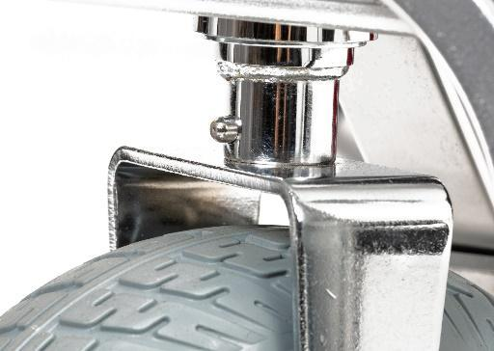
For a video of initial setup, please type in the following address into your search bar: https://youtu.be/wFGhS9gDuWg or just go to our YouTube channel.

Attaching the Front Wheel
Attach the front wheel to the main frame of the TravelScoot by inserting it into the steering column. Make sure that the spring-loaded button (1) locks into the corresponding hole. If you are met with resistance, raise the handlebars slightly and try again.
1

Unfolding your TravelScoot

To unfold your TravelScoot, push the steering column forward slightly while pushing on the locking pin. Doing so will relieve pressure on the pin and allow it to engage easier. When the scooter is fully unfolded, you will hear an audible click to signify that the scooter is in the unfolded position. There are three locking pin stages.

Stage 1: Folded position (2a)
Stage 2: Limbo position (2b)
Stage 3: Unfolded position (2c)
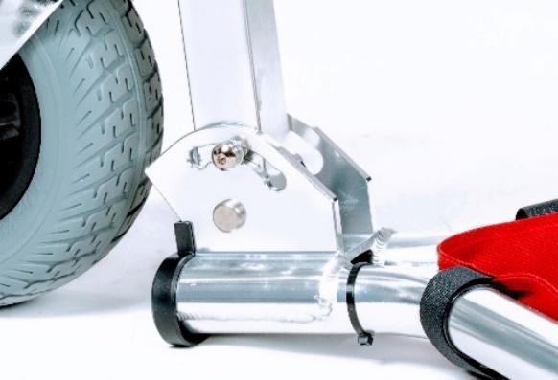
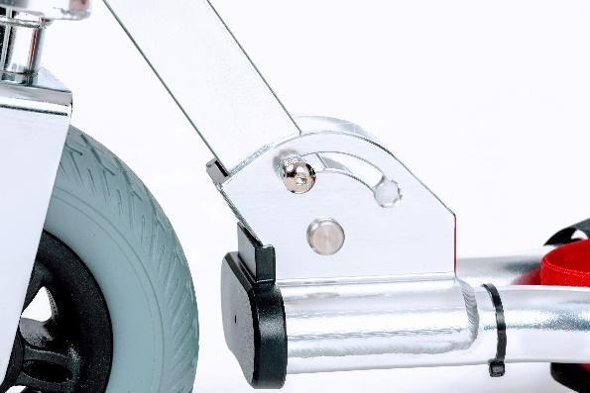
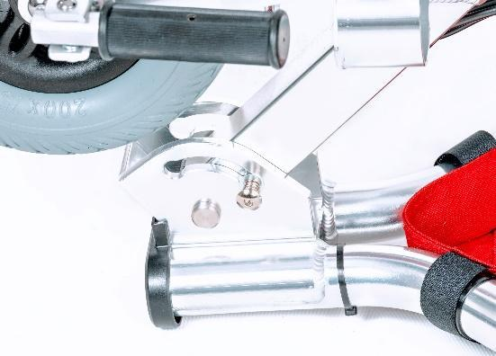
2c
2b
2a

Handlebar Height Adjustment
3a: Locate the lever clamp.
3b: Open the lever clamp.
3c: Adjust to the desired height and close the lever clamp.
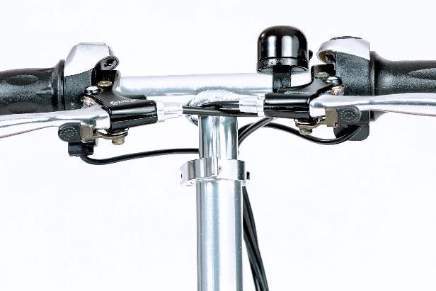
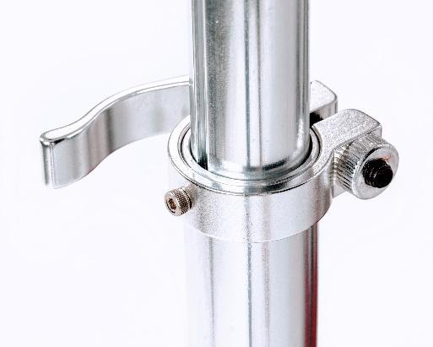
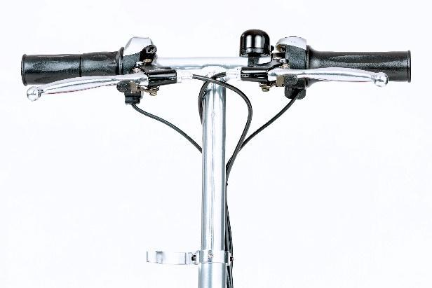
3a
3b
3c
Footrest Assembly
The only assembly required in setting up the TravelScoot is the footrest. Using the largest Allen wrench in the included toolkit:
5a) Position the footrest assembly with the cane holders either facing towards or away from the scooter
5b) Place the cane holders underneath and behind the mounting block
5c) Raise the footrest assembly to the mounting block
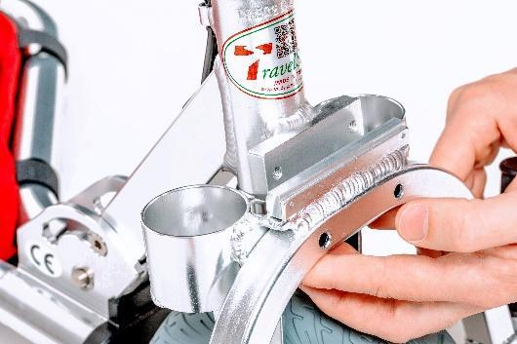
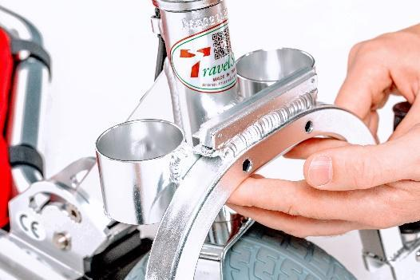
5d) Tightly screw in place, first by hand, then using the Allen wrench
Cane Holders
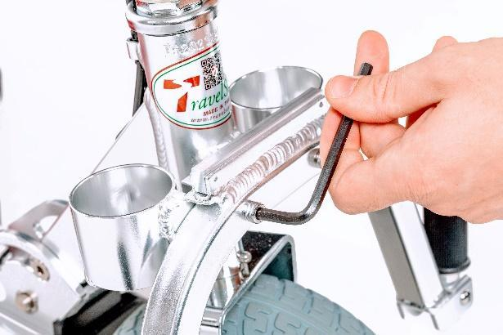
5a
5b
5c
5d
5e

Battery Installation
4a): Place the battery into the Velcro-lined tray between the rear wheels of the scooter with the battery plug facing the rear-left wheel.
4b): Connect the battery plug to the corresponding receptacle situated in front of the left wheel.
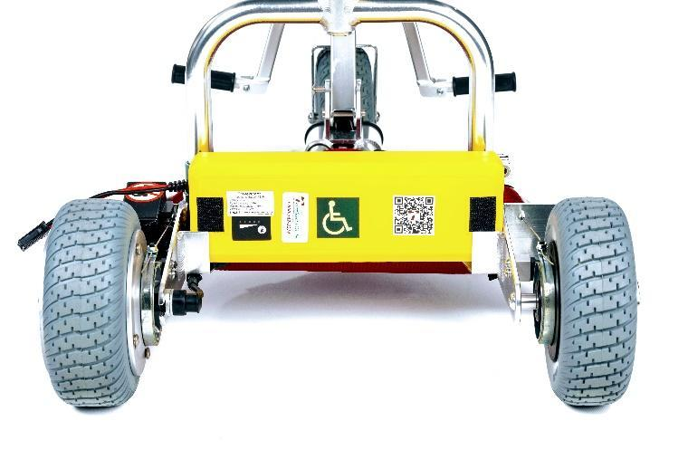
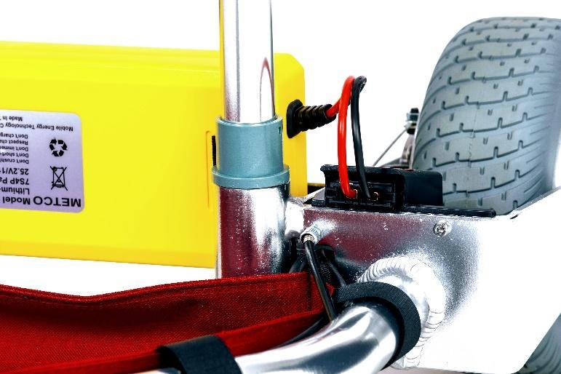
4a
4b

Seat Assembly

- Place the seat cushion face down on an elevated surface and insert the yoke upside down into the seat post until the yoke is fully inserted then tighten the yoke clamp.
- Insert the backrest elbow into the seat bracket receptacle and depress the spring lock.
- Slide in place until the spring lock is through and you hear an audible click.
- While holding the seat, insert the yoke evenly into the seat receptacles (plastic bushings).
- Once the yoke is in place, tighten the lever clamp.
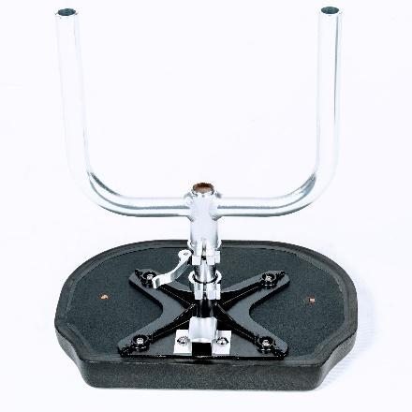
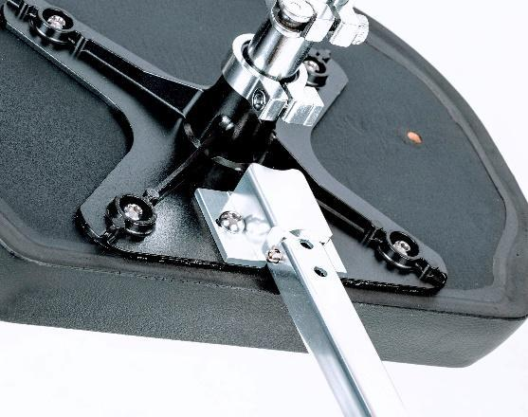
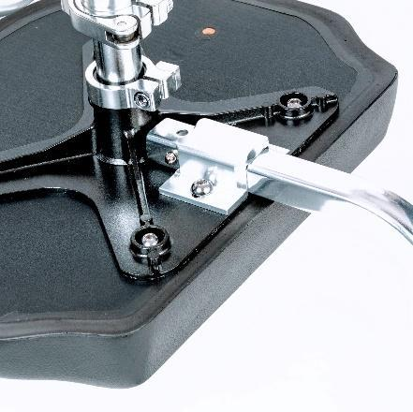
5a
5b
5c

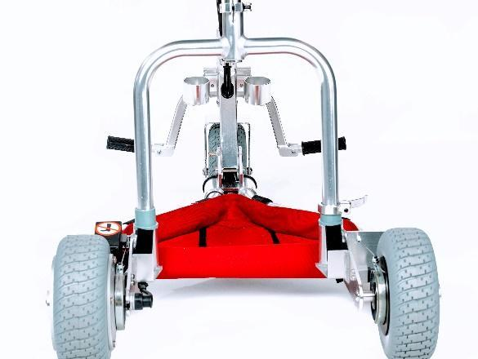
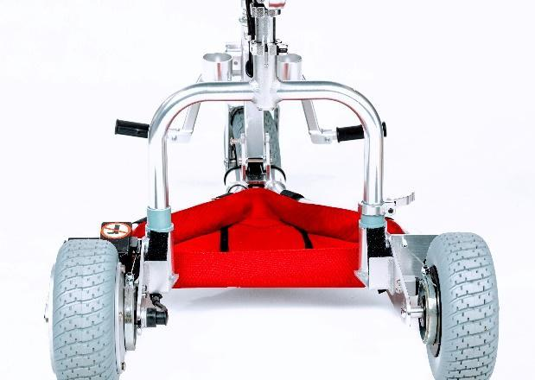
5d
5e

Backrest Height Adjustment
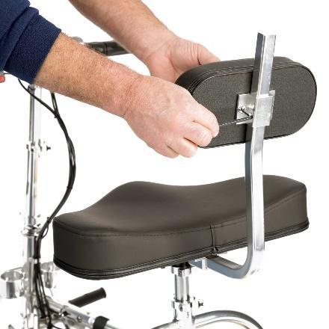
The backrest on the TravelScoot can be adjusted to your comfort. Using the largest Allen wrench in the included toolkit, simply loosen the two bolts holding the backrest cushion to the backrest stem, move the cushion to the desired height and re-tighten the bolts.

Seat Spacers

Included with your TravelScoot are two seat spacers. They are to be used to raise the seat up to maintain seat height. Once the desired height has been determined, the spacers can be attached to the seat post using adhesive tape, Loctite, silicone, epoxy, etc. When attaching the yoke, ensure that there are no gaps between the seat post and the bottom receptacle of the yoke (all they should be, at most, flush for your safety).

Installing the Fabric Caddy

The machine-washable Fabric Caddy is ideal for carrying light-weight items such as jackets, cameras, etc. To fasten the fabric caddy to your TravelScoot:
- Align the Velcro straps on the fabric caddy with the corresponding six Velcro rings on the TravelScoot trailing arms
- Secure firmly.
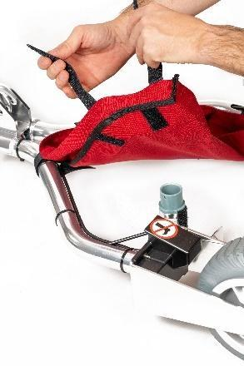
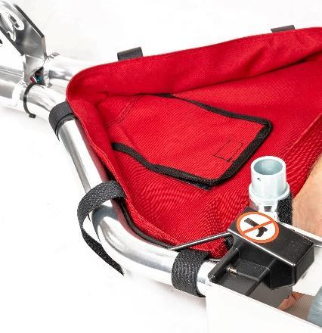
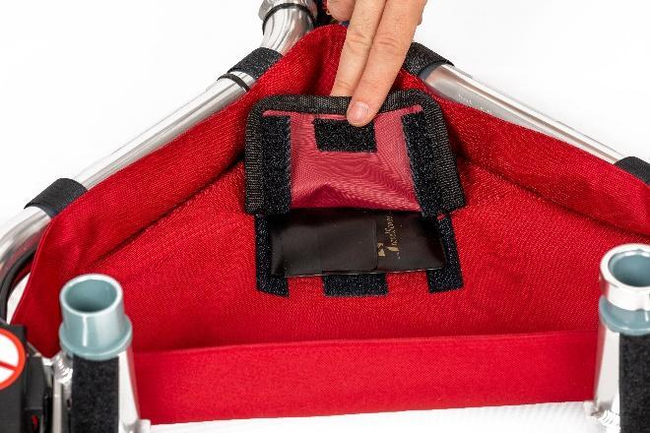
- There is a pouch on the caddy for your tool kit.
6a
6b
6c

Folding your TravelScoot
- Ensure that the power button (located on the left handlebar) is in the “OFF” position.
- Open the steering column lever clamp, lower the steering column to the desired height and tighten.
- Remove the seat assembly by releasing the lever clamp holding the yoke.
- With one hand on the steering column, apply slight forward pressure to relieve tension on the locking pin.
- Press the locking pin and collapse the scooter until you hear an audible click.

Battery Charging Procedures
The battery smart charger supplied with your TravelScoot is proprietary to your lithium-ion battery. Do not attempt to use it with other batteries nor attempt to charge your TravelScoot battery with a non-TravelScoot-issued charger. To charge the battery:
- Plug the power cord into an AC outlet then plug it into the battery charger.
- A solid red light will appear. The solid red light indicates your AC outlet works (7a).
- Plug the charger into the battery.
- (7b) You will now see either two solid red lights (indicating that the battery is charging), or (7c) you will see one red light and one green light (indicating that the battery is fully charged).
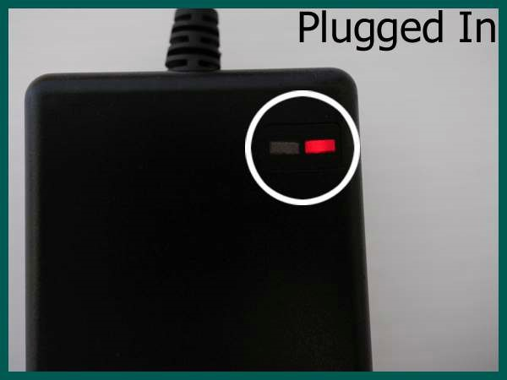
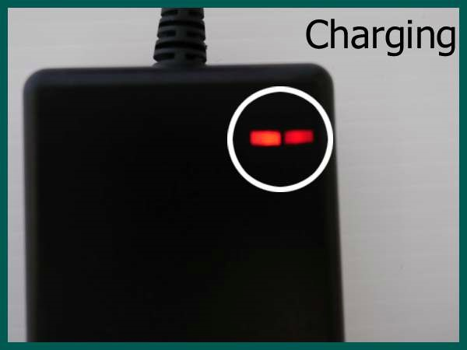
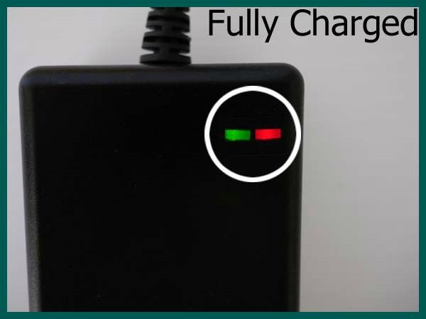

7c
7b
7a

Additional Battery Information
Unlike traditional batteries, TravelScoot lithium-ion batteries have no memory. This means that the battery can be charged, or “topped off”, at any time. Likewise, the charging process can be interrupted at any time without negatively affecting the battery. Typical charging time for a completely discharged battery is 4 to 6 hours.
Note: We recommend unplugging the battery charger from the AC outlet when not in use.
Battery Info for Foreign Travel
The TravelScoot lithium-ion battery charger is universal, and will operate on 100-240 VAC, 50/60 Hz. This allows it to be used internationally in conjunction with a plug adaptor which can be found at most department and electronic stores.
Battery Tips
- Disconnect the battery when not using your TravelScoot.
- Do not expose your battery to excessive heat or cold.
- Avoid excessive exposure to water.
- Do not drop.
- The battery should be charged with a METCO charger: RL07-16XX.
- We recommend charging the battery once the battery is used.
- For storage purposes, it is recommended to fully charge the battery at least every 3 months.
- Store the battery in a cool, dry place when not in use.
- Monitor the battery indicator lights, located on the throttle to best gauge your personal battery consumption. Remember that each light represents roughly 1/3 of the battery’s total charge. Consumption will vary depending on how much you travel on uneven terrain.
- If possible, try to avoid total discharge of the battery. Repeatedly draining the battery all the way can shorten its lifespan.

Getting On and Off of the TravelScoot
Before getting on or off of your scooter, please ensure that the parking brakes (see pages 13 and 14) are engaged and the power is off. Be sure to center your weight on the TravelScoot for support when mounting or dismounting.

Operating your TravelScoot
Connecting the Battery
Connect the battery connector into the black plastic receptacle at the front of the left-rear wheel fork (disconnect by pressing both sides of the battery connector).
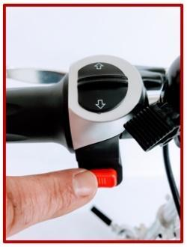
On/Off Switch and Forward/Reverse Selector
The On/Off switch and Forward/Reverse selector are found on the left handlebar. To turn the scooter on, simply press the red button. Repeat to turn the scooter off.
As a safety measure, always check the forward/reverse selector to ensure you are traveling in the desired direction before engaging the throttle. Position the selector upwards to go forwards, and downwards to go backwards.
Caution: Do not move the scooter in the opposite direction of the desired movement selection (e.g., do not push the scooter in reverse if you have the scooter in the forward position and vice versa).

Throttle
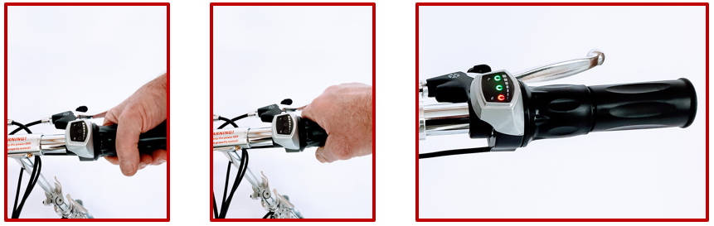
The throttle is located on the inside half of the right-hand grip. To get used to operating the throttle, turn the twist-grip slowly and smoothly towards yourself, similar to a motorcycle. Use the same twisting motion for both forward and reverse operation. Turning the throttle too quickly can result in unexpected acceleration or even tipping over. The throttle on the TravelScoot has an electronic delay from the moment you engage it until power is applied. This safety feature prevents uncontrolled acceleration.

The TravelScoot features battery charge indicator lights, located on the throttle display. There are two green lights and one red light, each light representing roughly 1/3 of the battery’s total charge. It is a good idea to monitor how soon each light goes out so as to better estimate how long your battery will last. Keep in mind that the terrain over which you travel will greatly determine overall mileage.
Brake Levers
The TravelScoot does not have automatic brakes. Instead, it uses band brakes. Band brakes are very effective, even on downhill grades. Each rear wheel has its own band brake that is controlled by the corresponding lever. For maximum stopping power, both brake levers must be applied. Safety dictates, however, that while driving downhill, to never exceed a speed faster than you could walk. Caution is also advised on steeper uphill grades when forced to stop. The band brakes are less effective when rolling backwards. Therefore, it is advisable to avoid riding up or down steep inclines and, instead, get off and push the TravelScoot to a more level location. Do not apply the throttle while engaging the brakes. This could result in tipping.
Parking Brakes
Both brake levers are equipped with a parking brake. It is strongly advised to use the parking brakes before getting off or on your scooter. There are two positions the parking brake lever can be in. Position 1 can be used on level surface. Position 2 should be used if the scooter is on an incline.
To engage the parking brakes:
- With one hand, apply pressure to the parking brake
- With your other hand, squeeze the brake lever until you hear an audible click for position 1
- Continue to squeeze if you would like to set the brake lever for position 2
8a
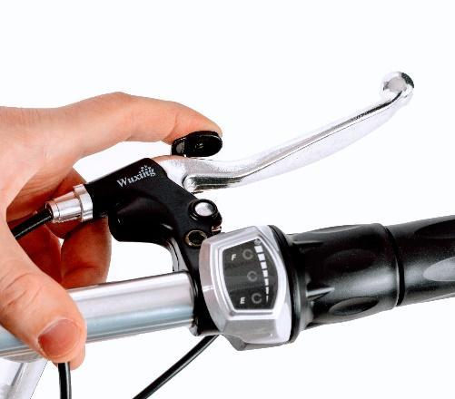
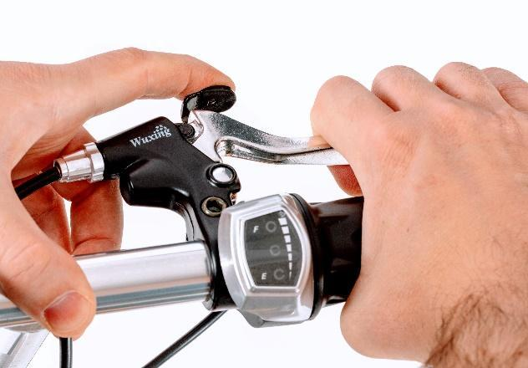
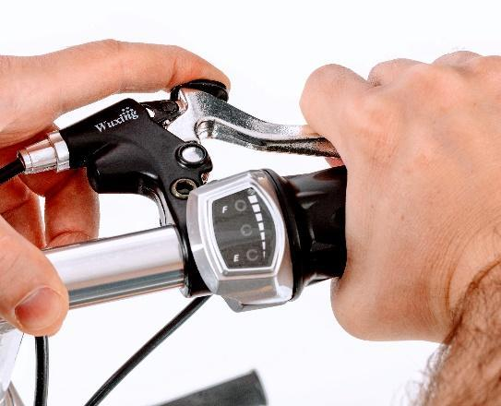
8b
8c

Turning with your TravelScoot
Left turns (9a): Because the drive motor is located on the left-rear wheel of the TravelScoot, left turns from a stopped position are only possible with the front wheel turned no more than 45 degrees. If you attempt to accelerate from a stopped position with the front wheel turned more than 45 degrees to the left, this will result in blocking the drive and “pushing” the front wheel. If this is done on any sort of uneven terrain, it could result in an uncontrolled situation. Turning left with the front wheel less than 45 degrees still provides an adequate amount of maneuverability similar to that of a four-wheeled scooter. However, when already in motion, tighter turns are possible.
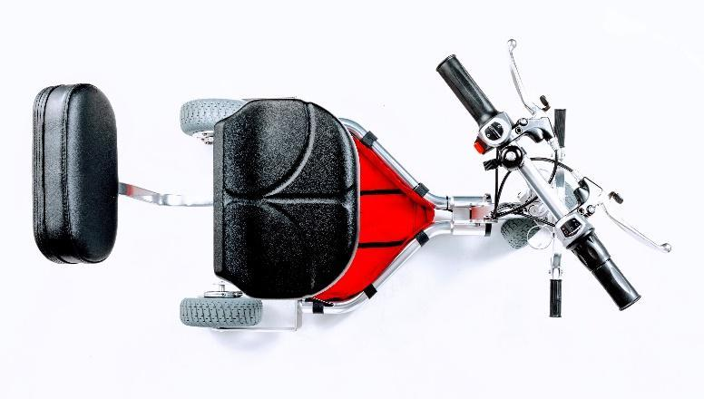
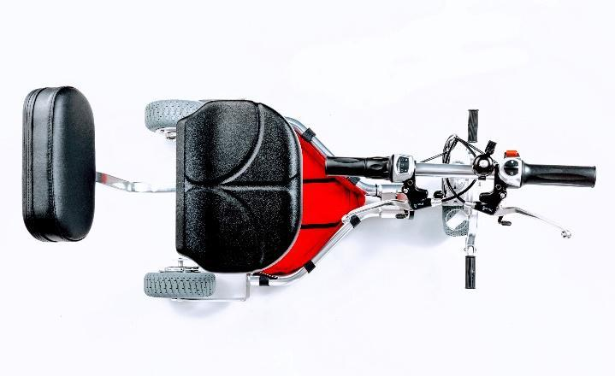
Right Turns (9b): Right turns on the TravelScoot are where its agility and nimbleness really shine. Right turns of up to 90 degrees from a stopped position are possible, but be sure to use very little throttle when doing so. The TravelScoot virtually turns on the spot. Practicing your turns on the TravelScoot will be invaluable in situations where there may not be much room such as on elevators or in public restrooms. You will learn to approach these confined spaces so that you can exit with a right turn.
9b
9a
45°
90°

Maintenance
Due to the innovative design of the TravelScoot, it is nearly maintenance free. A small tool kit is included with the scooter which can be used to tighten the bolts of your TravelScoot. It is recommended that you follow the steps below every six months (or as needed) to ensure that your scooter performs flawlessly for years to come.
Cleaning Tips
Keeping your TravelScoot clean and dry is important. Remove dust and dirt from the frame components with a mild dish soap solution or water-resistant silicone spray (preferred). Do not use abrasive or alkaline cleaners as these will attack the finish. Using a microfiber cloth, wipe any accumulated moisture from the frame and components after riding in damp conditions. These simple measures will help maintain the reliability and safety of your TravelScoot. For more on cleaning and maintaining the TravelScoot, check out our videos at www.travelscootusa.com.
Brakes
The brakes can be adjusted at three different locations:
- At the hand brake lever
- Cable conduit (front of rear-wheel fork)
- At the band brake itself (8mm wrench required).

Lubrication

For lubrication we recommend a dry, water-resistant silicone or Teflon spray. Avoid oils and greases as they attract dirt. Light lubrication should be applied periodically to the following areas:
- Steering column
- Locking pin
*All wheel bearings are sealed and do not require lubrication.
Tightening
Please inspect and tighten the following fasteners:

Rear left axle nut (make sure this is as tight as possible)

Seat and backrest screws

Travel Tips
Air Travel
Policies and handling practices differ from one airline to another. We recommend that you contact your airline’s Special Needs Coordinator, or equivalent, well in advance for specific information regarding air travel for passengers with mobility devices. Request your approval confirmation in writing if possible. Do not expect each airline agent to be familiar with the many policies and regulations that pertain to mobility devices.
Note: Customers have been traveling by air using the TravelScoot since 2004. The TravelScoot was designed with air travel in mind.
TIP: Battery documentation for air travel can be found online at https://www.travelscoot.com/air-travel-with-an-electric-mobility-scooter.html.
At the Airport
At the security checkpoint you can usually bypass the waiting crowd by asking for assistance. Security may ask you whether or not you can stand. To avoid being subjected to a body search, stand up (if possible) and walk the few feet through the x-ray frame. They will perform a security check on your scooter. After you are cleared you can drive your TravelScoot to the gate.
At the check-in desk, remain seated so that an employee will understand that you have walking problems. Your attendant at the boarding gate will give you your “Gate Delivery” tags for your scooter. While you wait to board your plane, be sure to listen for the pre-boarding announcement for people with disabilities and families with small children. They are asked to board before the rest of the passengers so that baggage handlers have enough time to store medical equipment and strollers in the luggage compartment. Therefore, we suggest that you arrive at the airport early.
Once at the door of the airplane, lower the handlebars, remove the battery, and hand the scooter over to the baggage attendant. If you wish to fold up your scooter, be sure to securely attach the seat before handing it off to the attendant. Scooter components will get lost if not kept together. We also suggest covering the handlebars of the scooter with padding or the TravelScoot Travel Set to protect the controls from possible damage due to careless baggage handlers.

International Air Transport Association (IATA) Lithium Guidance Battery Document
The following documentation consists of the most recent regulations relating to Airline Travel with Lithium-ion batteries. If you are travelling by air, bring this manual with you or photocopy this page, as not all airline representatives may be familiar with the most up-to-date battery regulations.
(Official Excerpt)
2.3.3.2
Lithium-ion battery powered wheelchairs or other similar mobility aids for use by passengers whose mobility is restricted by either a disability, their health or age, or a temporary mobility problem (e.g. broken leg), are permitted in air transport but subject to the following conditions:
(a) the batteries must be of a type which meets the requirements of each test in the UN Manual of Tests and Criteria, Part III, subsection 38.3;
(b) the operator must verify that:
- battery terminals are protected from short circuits, e.g. by being enclosed within a battery container,
- the battery must be securely attached to the wheelchair or mobility aid; and
- electrical circuits have been inhibited.
- the mobility aids must be carried in a manner such that they are protected from being damaged by the movement of baggage, mail, or other cargo;
- where a battery-powered or other similar mobility aid is specifically designed to allow its battery(ies) to be removed by the user (e.g. collapsible)
- the battery must be removed. The wheelchair / mobility aid may then be carried as checked baggage without restriction;
- the battery must be protected from short circuit by insulating the terminals (e.g. by taping over exposed terminals);
- the removed battery must be protected from damage (e.g.) by placing each battery in a protective pouch. The battery must be carried in the passenger cabin;
- removal of the battery from the device must be performed by following the instructions of the manufacturer or device owner;
- the battery must not exceed 300 Wh
- a maximum of one spare battery not exceeding 300 Wh or two spares each not exceeding 160 Wh may be carried; and
- the pilot-in-command must be informed of the location of the mobility aid with an installed battery or the location of the lithium battery when removed and carried in the cabin.
- It is recommended that passengers make advance arrangements with each operator.

Cruise Ship Travel
Ahoy TravelScoot! The TravelScoot is the number one choice for travelers venturing out to sea. With its compact size and maneuverability, you would think the TravelScoot was custom-built for cruising. Both the Escape and Cruiser models should fit all doors on whichever cruise you choose.
In Your Cabin
Let's face it, cruising is a fantastic way to see the world, but the cabins can be a little on the small side. For safety reasons, cruise lines prohibit you from leaving your mobility scooter outside your room in the hall. You must store it inside your cabin. With other scooters, this can be a real nuisance as you try to maneuver around an already small space. With the TravelScoot, however, you can fold it up and store it in a closet, in a corner of your cabin, or park it right under the desk in your room.
On the Ship
Most cruise ships nowadays seem to be the size of a small city! Exploring the ship can be adventurous but tiring. Quite often there are many different levels on these ships which can pose a problem for someone with difficulties getting around. The TravelScoot makes small work of these vast ships. Whether you are scooting to the pool, on the Lido deck, or to the Fiesta deck for an evening of fine dining at a formal dinner, the TravelScoot will take you wherever you want to go.
On-Shore Excursions
Exploring the many different ports and excursions a cruise ship has to offer is a wonderful way to travel the world. In some ports, cruise ships have to anchor offshore and tender the passengers to shore. Most cruise lines won't allow mobility devices over 50 lbs./22.7kg on these tenders. But at a mere 34 lbs./15.87kg, the TravelScoot is no problem.

Specifications
Dimensions (in inches):
Folded | Unfolded
Length = 29.5 or 34 (w/front wheel) | Length = 36.25
Width = 21.25 | Width = 21.25
Height = 10.25 | Height = between 28 and 34.5

Weight (lbs.)
Scooter Frame | 21
Front Wheel | 3.2
Seat Assembly | 6.3
274 Wh Battery | 4
151 Wh Battery | 3.1
420 Wh Battery | 5.5
Maximum Speed | 4.5 mph
Distance per charge | Distance will vary on terrain, rider weight, and frequency of stop-and-go operation.
274 Wh Battery | 12-15 miles
151 Wh Battery | 6-8 miles
420 Wh Battery | 16-22 miles
Warranty Weight Limit | 350 lbs.
Motor | 24V, 200 Watt DC
Tire Size | Front 8x2.86 inches, Rear 8x2.5 inches
Charger | 100/240VAC, 50/60Hz 24VDC/2Ah
Charging Time | 6-8 hours
Brakes
Levers | Manual
Brake Type | Mechanical band brake w/ parking brake
Drive | Rim motor inside the rear left wheel
TravelScoot Components & Controls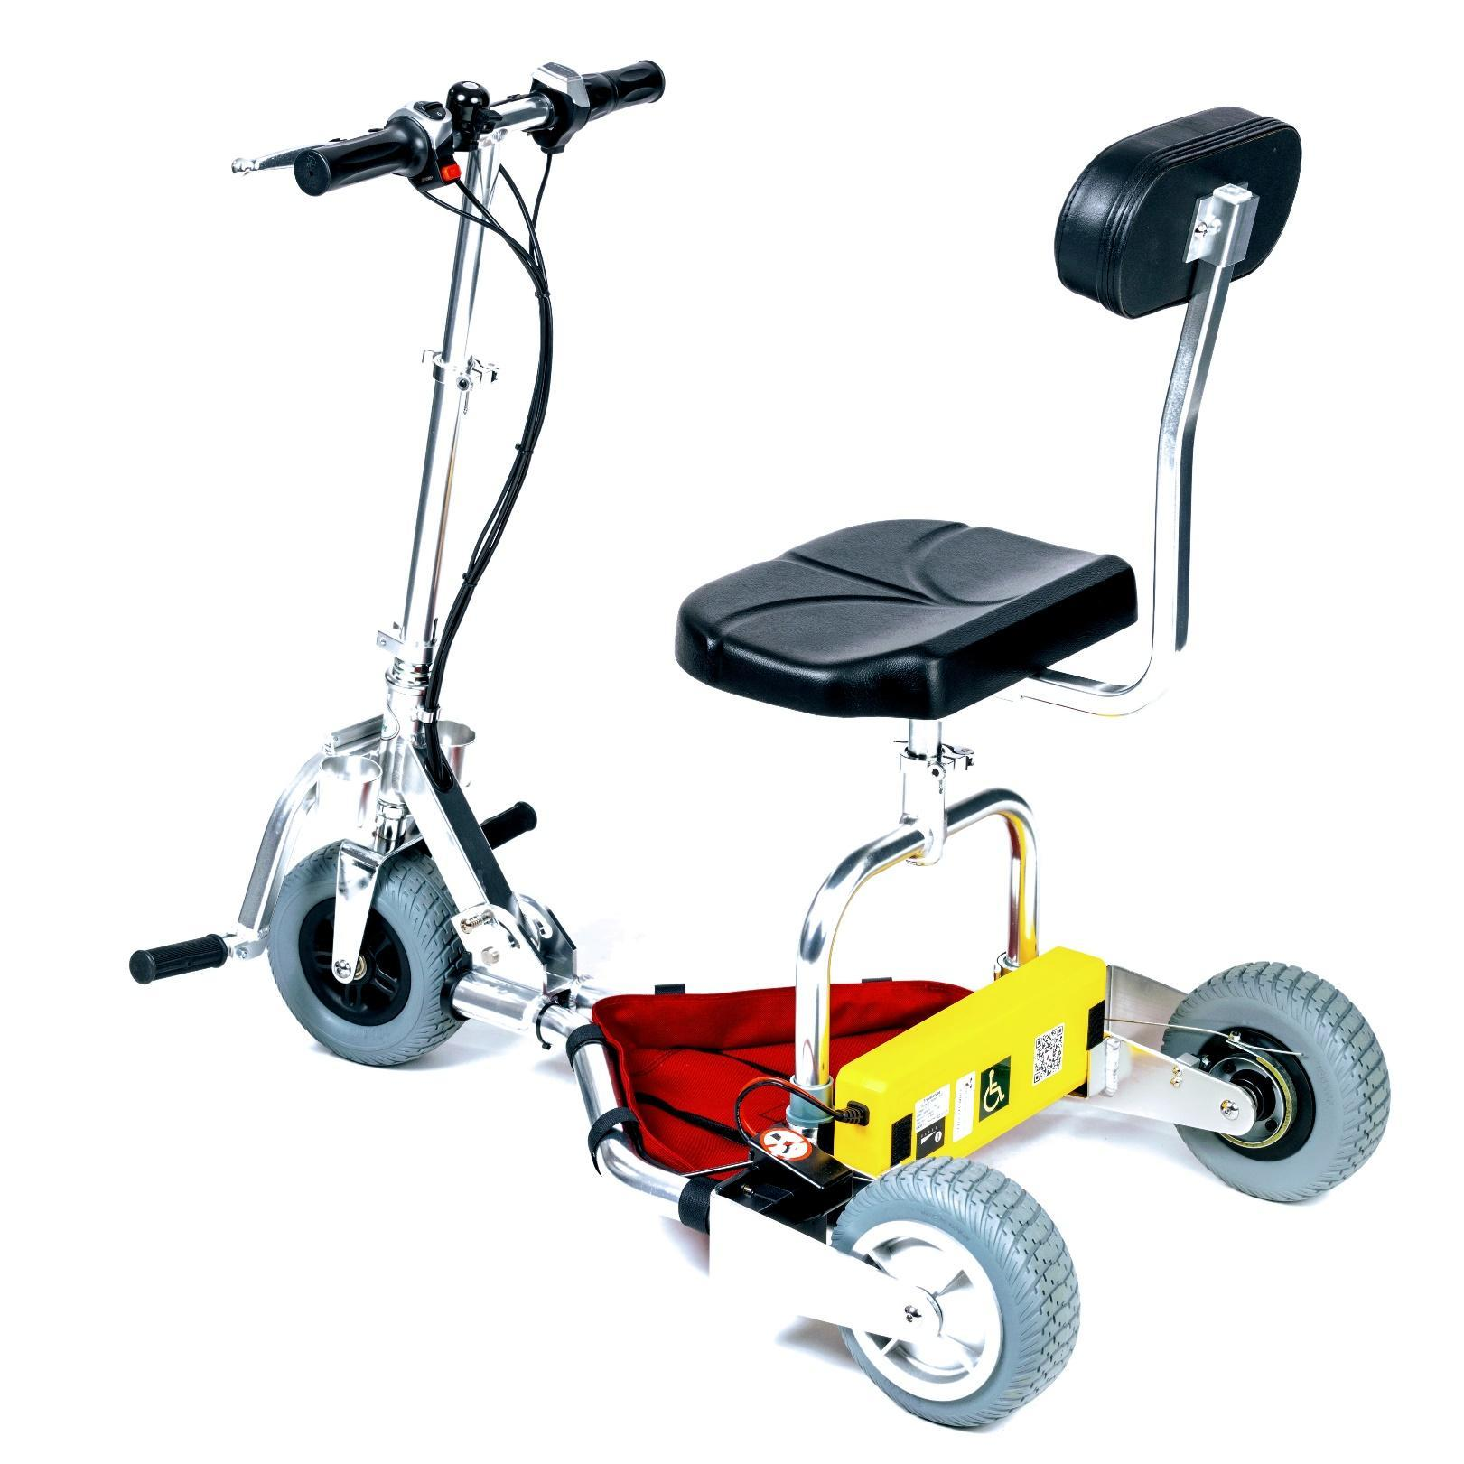
12
11
16
15
14
13
10
1
2
3
4
5
6
7
9
8
- Throttle  - Bell  - Forward/Reverse Selector  - Manual Brake  - On/Off Switch  - Steering Column Clamp  - Basket Rail  - Cane Holder | - Foot Peg  - Locking Pin  - Battery Charging Port  - Drive Motor (inside hub)  - Brake Band  - Seat Clamps  - Backrest Elbow  - Adjustable Backrest

